COURSE MATERIAL:
CO1: MATEMATICAL OPTIMIZATION
TOPIC1:

Optimization Problems & Applications Across Disciplines in Mathematical Optimization
1. What is an Optimization Problem?
An optimization problem is a mathematical problem of finding the best solution from a set of feasible solutions. It typically involves:
- Objective Function: A function to be maximized or minimized.
- Decision Variables: The variables that affect the outcome.
- Constraints: Conditions that must be satisfied.
Mathematical Form (General)
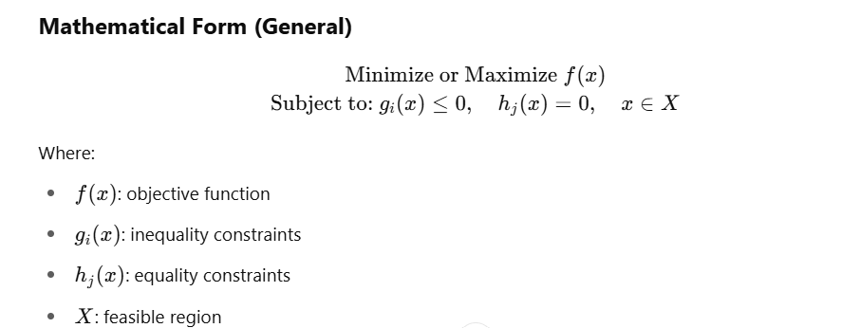

2. Types of Optimization Problems
- Linear Programming (LP): Objective and constraints are linear.
- Nonlinear Programming (NLP): At least one nonlinear component.
- Integer Programming (IP): Variables restricted to integers.
- Dynamic Programming: Sequential decision-making.
- Convex Optimization: Convex objective and feasible region.
- Stochastic Optimization: Deals with uncertainty in data.
- Combinatorial Optimization: Deals with discrete structures.

3. Applications Across Disciplines
A. Engineering
- Civil/Mechanical Engineering: Design optimization of structures (e.g., trusses, bridges).
- Electrical Engineering: Circuit design, power flow optimization.
- Control Systems: Optimal control for dynamic systems.
B. Computer Science
- Machine Learning: Model training (e.g., minimizing loss function).
- Scheduling: Job-shop and task scheduling.
- Network Design: Routing, bandwidth allocation, load balancing.
C. Operations Research
- Logistics: Supply chain optimization, vehicle routing.
- Resource Allocation: Staff scheduling, inventory management.
- Project Management: Critical path and cost minimization.
D. Economics & Finance
- Portfolio Optimization: Maximize returns, minimize risk.
- Game Theory: Nash equilibria, strategic decisions.
- Pricing Models: Revenue maximization under constraints.
E. Healthcare
- Radiation Therapy Planning: Optimize dosage while minimizing damage to healthy tissue.
- Hospital Resource Allocation: Beds, staff, and equipment optimization.
F. Environmental Science
- Energy Optimization: Renewable energy allocation, grid optimization.
- Water Resource Management: Irrigation planning, reservoir management.
G. Telecommunications
- Signal Processing: Filter design, error correction.
- Network Optimization: Maximizing throughput, minimizing latency.

4. Real-World Case Examples
- Google Maps: Uses optimization algorithms for shortest path.
- Amazon: Uses optimization in warehouse logistics and delivery routing.
- Finance: Algorithms for real-time trading optimize portfolios.

Conclusion
Mathematical optimization is a fundamental tool that cuts across disciplines. It provides the framework to model, solve, and interpret real-world decision-making problems effectively and efficiently.

